Graphics Lesson

We are going to draw a city scape with buildings, windows, sky, sun, and superman

Theory using white board

# Setup

* New JavaProject – GraphicLecture
* Download super.gif from BB
* Create a new JFrame – GraphicsPlay
  + Play around with graphics
  + 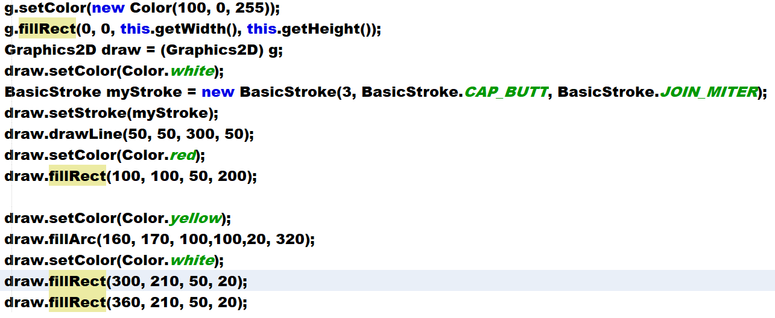
  + Draw a bunch of vertical lines 20 pixels apart
  + 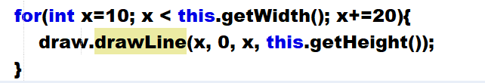
  + Draw a bunch of horizontal lines 20 pixels apart
  + 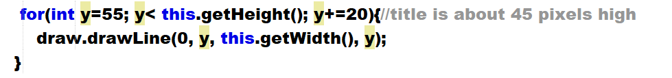
  + Move to a method  
    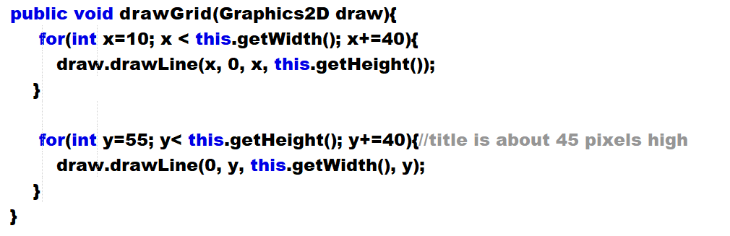
  + Move to above the drawing above line and
* Create a new JFrame called CityScape
* Create these variables to start  
  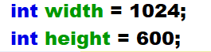
* In constructor set the width and height of the form  
  
* Insert code and override Window.Paint
  + Paint draws the window
  + Everytime you move, resize the window Paint is called
  + Define g
* Add to paint to start drawing
* Set color of form
  + 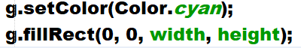
* Draw the sun  
  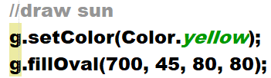
* Draw some blue buildings  
  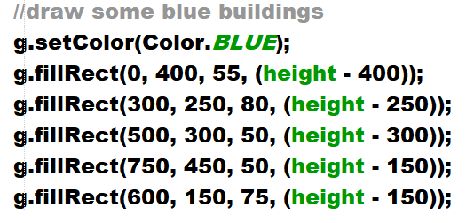
* Add some different colors if desired
* Add superman by drawing an image
  + Variables  
    
  + In paint  
    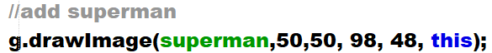
* Random buildings – call at bottom of paint
  + 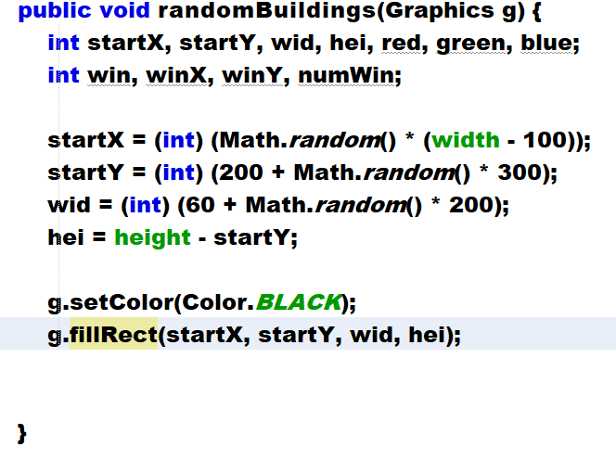
* Make form respond to click and redraw random buildings
  + Click on form and add mouse clicked event
  + Add this line to event handler for practice  
    
* Change event handler to redraw city  
  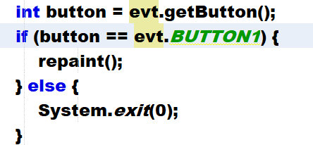
* Provide directions in sky – add to constructor somewhere  
  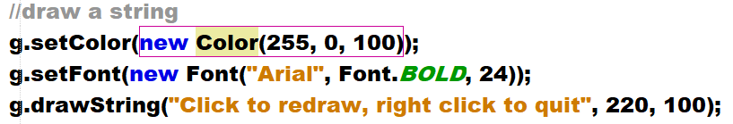
* Make city completely random
  + Comment out the blue buildings code
  + Modify randomBuilding()
  + **Change existing fillRect to drawRect**
  + Add this above the g.setColor(Color.BLACK)  
    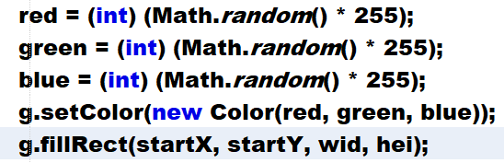
  + Change
  + Run should see buildings drawn in colors with black border - borderlands style
  + Now draw 15 buildings
  + Surround everything except the variables with this loop
  + 
* Now create windows on the buildings
  + 3 windows across
  + Rows of windows = height of the building / width of window
  + The window will start ½ of the width of the window from the left edge of the building
  + Windows will be square – size is 1/6th of the width of the building
  + Add this to the end of the for loop in randomBuildings  
    